Grading Assignments Part 2
(Please note: All of these instructions are available in the Online Instructional Resources site on Blackboard. Go to Course Content > Lessons Folders from Blackboard Training > Lesson 6: Creating Assignments > Grading Assignments

Adding Comments and Feedback for Students to Assignments
Note: this feature does not work if a student simply types in the text submission box – they must attach a file.

Overview:
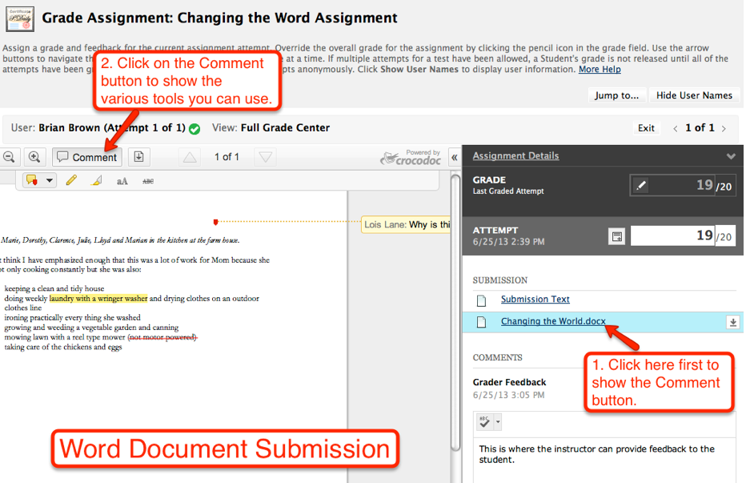
Comments Button

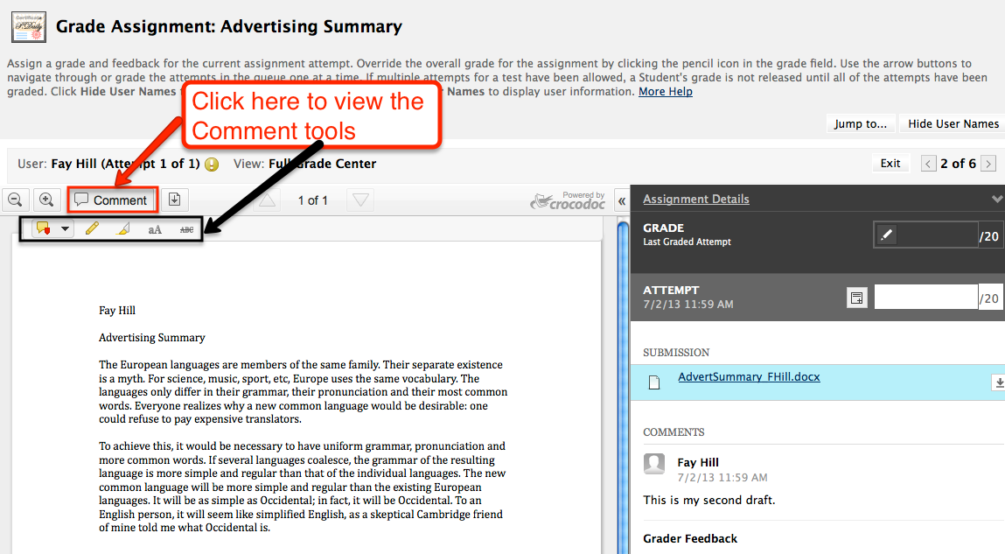

Enlarge View
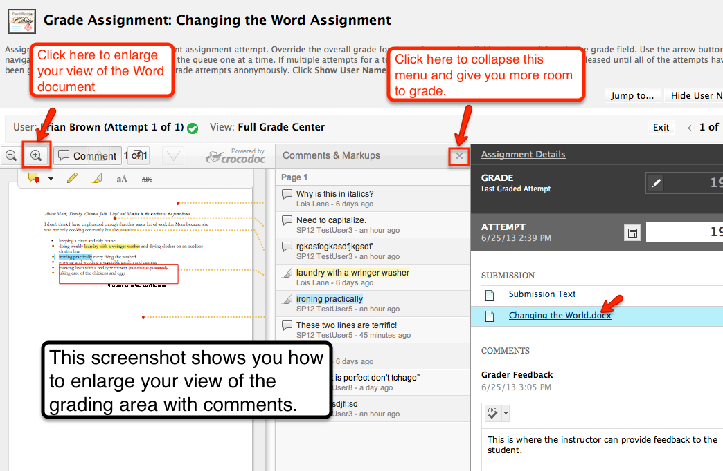

Call-Out Comments

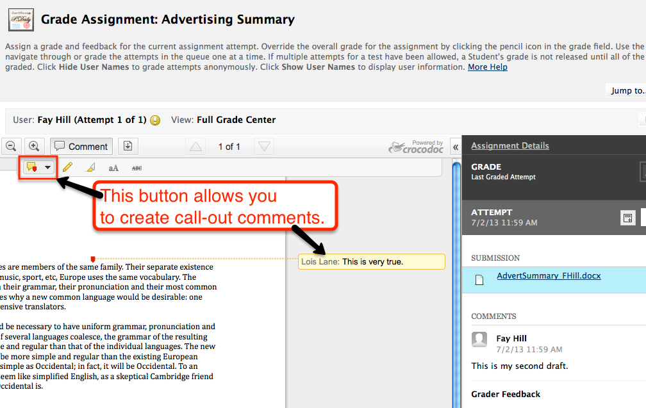

Drawing Tool

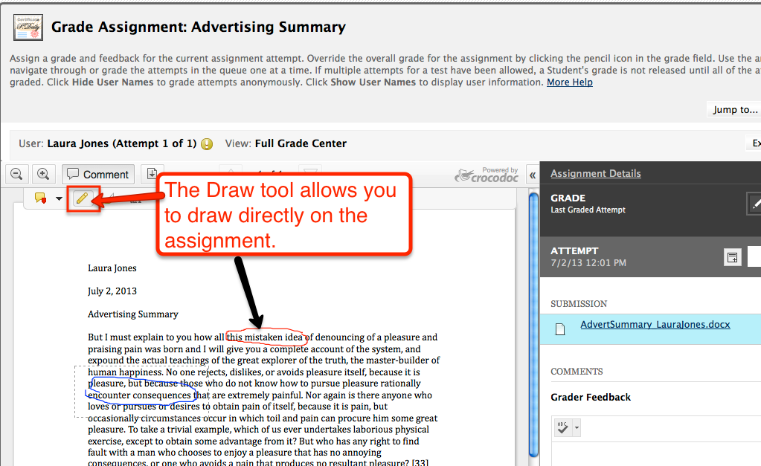

Highlight Tool

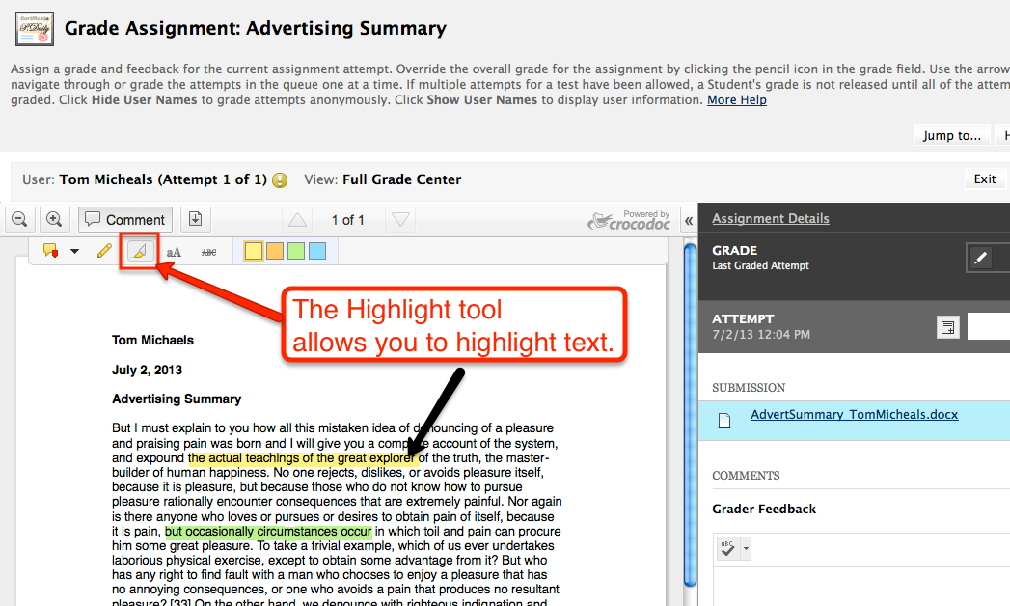

Text Tool

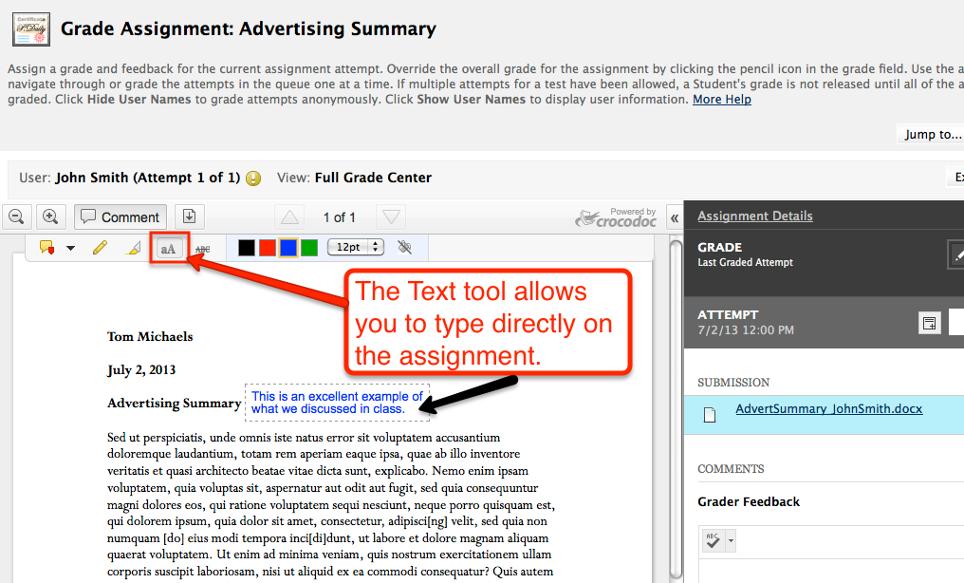

Strike Out Tool

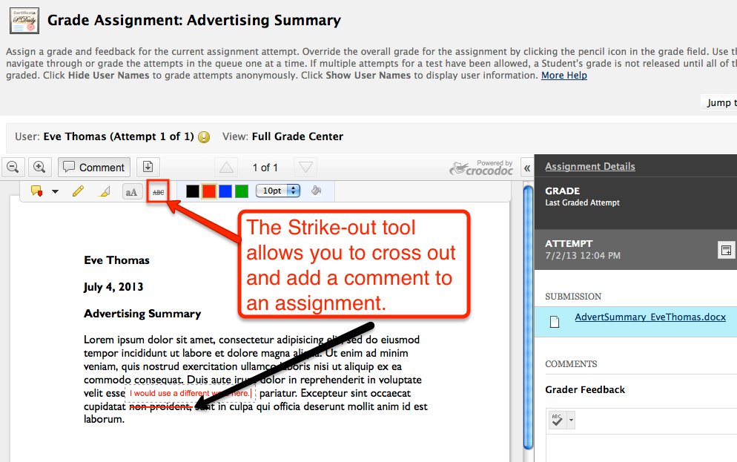

Submit Grade Button

